College of Saint Benedict & Saint John’s University

Computer Science Department

GABeS

Phase 2

Team Potatoes

Grant Boyer, Kyle Olson, Tom Husen

[This page has been intentionally left blank]

Table of Contents

Conceptual Database Design …………………………………………………………………………………………………... 4

EER Diagram ………………………………………………………………………………………………………………... 4

Explanation of EER Diagram ………………………………………………………………………………….……… 4

Entities …………………………………………………………………………………………………………………….….. 5

Attributes ………………………………………………………………………………………………………..…………… 5

Relationships ……………………………………………………………………………………………………………….. 5

Super/Sub Classes ………………………………………………………………………………………………………… 6

Constraints …………………………………………………………………………………………………………………… 6

Logical Database Design ………………………………………………………………………………………………………….. 7

Relational Map …………………………………………………………………………………………………………….. 7

Explanation of Relational Map ……………………………………………………………………………………… 7

Issues Faced During Phase ………………………………………………………………………………………………………. 8

Decomposition of Tasks …………………………………………………………………………………………………….…….. 8

Meeting Minutes ...………………………………………………………………………………………………………………….. 9

September 29th Minutes ………………………………………………………………………………………….….. 9

October 6th Minutes ………………………………………………………………….………………………………. 10

Conceptual Database Design *-* EER Diagram

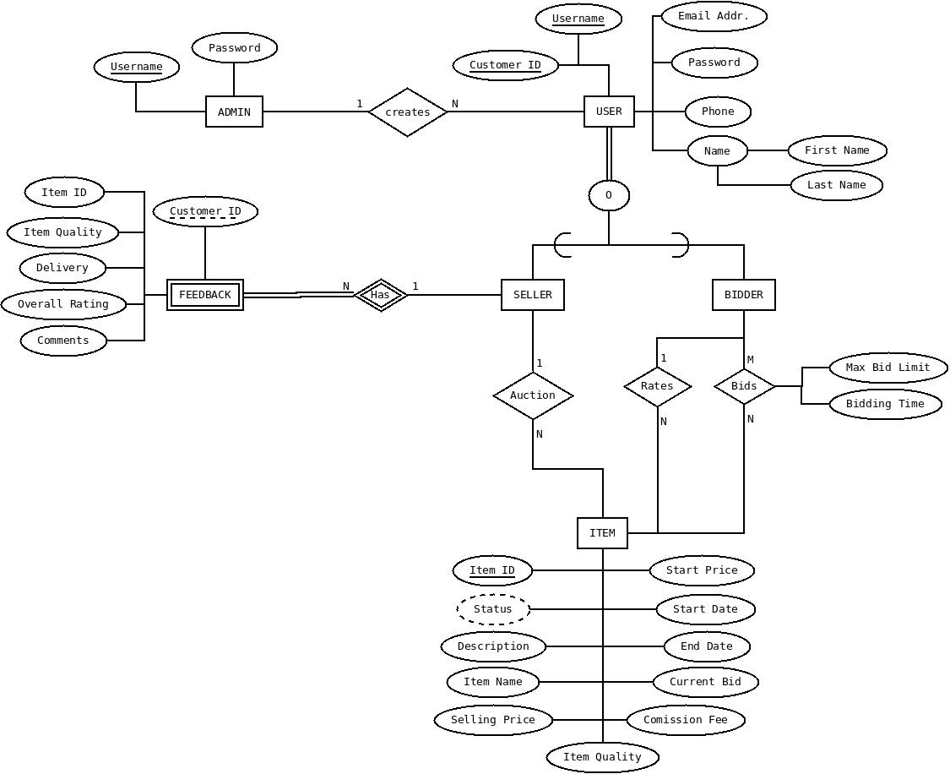Explanation of EER Diagram

Above is our EER diagram to conceptually model the GABeS database system. Within the diagram are many entities, relationships, and attributes (all of which are detailed on the following page). When creating this conceptual model, there were many routes we could take to accomplish the desired task. Some of the choices we made after much discussion and some were easier. One that required some discussion was how to link *Feedback* into the system – whether it was best to go through the *Item* or *Seller* entity. We eventually settled upon linking through the seller due to how we modeled our sites in phase 1, and the logical thinking of rating a transaction for a specific seller made the most sense to us. Our original thinking was a slightly complex 3-way relationship between Feedback, Seller, and Item but upon reviewing with Imad we learned this would only introduce unnecessary redundancy. All of this info can be obtained by navigating various branches of the diagram.

Entities

|  |  |  |  |
| --- | --- | --- | --- |
| Entity Name | Primary Key(s) | Number of Attributes | Entity Type |
| ADMIN | Username | 2 | Strong |
| USER | Customer ID, Username | 6 | Strong |
| SELLER | Customer ID | 0 | Strong |
| BIDDER | Customer ID | 0 | Strong |
| ITEM | Item ID | 11 | Strong |
| FEEDBACK | Customer ID | 6 | Weak |

Attributes

|  |  |  |  |  |
| --- | --- | --- | --- | --- |
| Parent Entity | Attribute Name | Attribute Type | Value Domain | Key Value |
| Admin | Username | Simple | String | Yes |
| Admin | Password | Simple | String | No |
| User | Customer ID | Simple | Integer | Yes |
| User | Username | Simple | String | Yes |
| User | Email Address | Simple | String | No |
| User | Password | Simple | String | No |
| User | Phone | Simple | String of Integers | No |
| User | Name | Composite | First and Last Name Strings | No |
| Item | Item ID | Simple | Integer | Yes |
| Item | Status | Derived | Boolean | No |
| Item | Description | Simple | String(s) | No |
| Item | Item Name | Simple | String(s) | No |
| Item | Selling Price | Simple | Double | No |
| Item | Item Quality | Simple | Integer (1-10) | No |
| Item | Start Price | Simple | Double | No |
| Item | Start Date | Simple | String | No |
| Item | End Date | Simple | String | No |
| Item | Current Bid | Simple | Double | No |
| Item | Commission Fee | Simple | Double | No |
| Feedback | Customer ID | Simple | Integer | Yes (Weak) |
| Feedback | Item ID | Simple | Integer | No |
| Feedback | Item Quality | Simple | Integer (1-10) | No |
| Feedback | Delivery | Simple | String(s) | No |
| Feedback | Overall Rating | Simple | Integer (1-10) | No |
| Feedback | Comments | Simple | String(s) | No |
| Bids (relationship) | Max Bid Limit | Simple | Double | No |
| Bids (relationship) | Bidding Time | Simple | Double | No |

Relationships

|  |  |  |  |
| --- | --- | --- | --- |
| Relationship Name | Cardinality | Entities Involved | Attributes |
| Creates | 1…N | Admin/User | None |
| Has | N…1 | Feedback/Seller | None |
| Auction | 1…N | Seller/Item | None |
| Rates | 1…N | Bidder/Item | None |
| Bids | M…N | Bidder/Item | Max Bid Limit & Bidding Time |

Super/Sub Classes

In our EER modeling diagram, we had one instance of specialization resulting in super and subclasses – with *User* being a super class for *Seller* and *Bidder*. This specialization has overlapping participation because on the site a user can be both a seller and/or and bidder. With the creating of the specialization, the EER diagram gains clarity and makes clear the functionality, relationships, and connections that are unique to each way the user can interact on the site.

Constraints

At this point we do not believe there are any constraints with our EER diagram. We believe it captures the full functionality of the GABeS site and does a good job of conveying how the database should conceptually be organized.

Logical Database Design – Relational Mapping

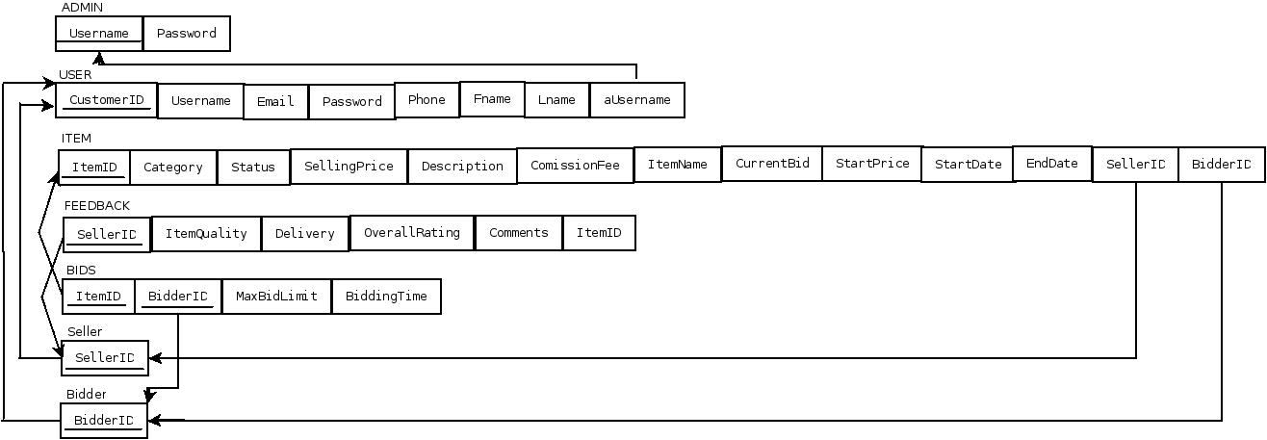

Explanation of Relational Map

Above is our relational map showing the connections that were originally represented by the EER diagram. This relational map takes advantage of both the foreign key and lookup table approach when modeling various types of relationships within the database. When deciding how to approach certain relationships we consulted examples from class, the book, and discussions with each other.

One example included the *Seller* and *Bidder* entities. Originally, we planned on having a lookup table for all of the relationships involved with these entities (*Bids*, *Rates*, and *Auction*). After further consideration we decided upon using the foreign key approach instead. By using this approach we prevented over complicating the map, creating unnecessary operations, and improving the quality of the model overall.

Should be noted: on the *BIDS* relation, the key is the combination of Item ID and Bidder ID. When creating our relational map we were unable to have both of these keys underlined with a single, connecting line.

Issues Faced

Many of the issues faced in this phase were quick to be fixed by our team and resulted in a greater understanding at the end. One of the bigger issues faced was Tom got quite sick for about 8 days which interfered with completion of the EER diagram at the deadline we had originally set.

When designing our EER diagram we did face some difficulties deciding what should be entities and how to best model some certain relationships. One such example is the View Reports and Create Reports functionality for the Admin. Our original approach was creating new entities and tying them into other relationships/entities within the EER diagram. After discussing amongst ourselves, and some help from Imad, we learned that all of the information contained in these reports could be derived through connections to other entities.

As discussed in the EER diagram there were also a few other minor stumbling blocks but overall this phase went very well for our team.

Task Decomposition

Grant:

* Created EER diagram draft
  + Worked with team to combine ideas and make final EER diagram
* Created relational map draft
  + Worked with team to combine ideas and make final relational map
* Typed relational map in DIA

Kyle:

* Created EER diagram draft
  + Worked with team to combine ideas and make final EER diagram
* Created relational map draft
  + Worked with team to combine ideas and make final relational map

Tom:

* Discussed ideas relating to EER diagram design
  + Typed final EER diagram in DIA
* Created relational map draft
* Compiled meeting minutes for our longer work sessions
  + Brief discussions (5-10 minutes) had no meeting minutes
* Compiled information for Phase 2 report

Meeting Minutes

Team Potatoes Minutes

September 29, 2016

Meeting began at 3:45 pm.

**In Attendance**:

* Grant Boyer
* Kyle Olson
* Thomas Husen

**Grant and Kyle**:

* Continue researching possible ways to improve EER clarity/efficiency – Done.

**Tom**:

* Convert final hand drawn EER diagram into typed DIA version – Done

**All**:

* Using drafts of EER diagrams created, combine into final copy
* Discuss possible issues/concerns about design
* For next meeting – using final EER diagram design, create draft of relational map which will be compared with other team mates designs

Meeting adjourned at 4:30 pm.

Team Potatoes Minutes

October 6, 2016

Meeting began at 10:45 am.

**In Attendance**:

* Grant Boyer
* Kyle Olson
* Thomas Husen

**Grant**:

* Convert hand drawn relational map into a DIA diagram – Done.

**Kyle**:

* Compile all other assorted info (notes, problems, decisions made, etc.) for use in the report – Done.

**Tom**:

* Compile all diagrams, resources, and notes into phase 2 report – Done.

**All**:

* Discussed any final changes to EER diagram we wanted to make
* Compared our relational maps, discussing any differences and agreeing upon what we believed to be the best possible map
* Talked about how the EER and relational map connected and how the functionalities would work
* Briefly talked about next steps we will take for phase 3

Meeting adjourned at 11:30 am.